

**AIML TRAINING REPORT**

## B.Tech. III Year

Department of Computer Science & Information Technology

**Name of the Student : Nidhi Mehta**

**Branch & section : CSIT-CI**

**Roll No. : 0827CI191039**

**Year : 2019-23**

## Department of Computer Science & Information Technology

**AITR, Indore**

**ACROPOLIS INSTITUTE OF TECHNOLOGY & RESEARCH, INDORE**

# Department of Computer Science & Information Technology

**Certificate**

Certified that training work entitled “ Industrial Training On AIML ” is a bonafied work carried out after sixth semester by “ *Nidhi Mehta* ” In partial fulfilment for the award of the degree of Bachelor of Technology in Computer Science and Information Technology from Prof. Vandana Kate Acropolis Institute of Technology and Research during the academic year 2022-23.

Prof. Vandana Kate

Associate Professor

**ACROPOLIS INSTITUTE OF TECHNOLOGY & RESEARCH, INDORE**

# Department of Computer Science & Information Technology

**ACKNOWLEDGEMENT**

I would like to acknowledge the contributions of the following people without whose help and guidance this report would not have been completed. I acknowledge the counsel and support of our training coordinator, Prof. Vandana Kate, Associate Professor, CSIT Department, with respect and gratitude, whose expertise, guidance, support, encouragement, and enthusiasm has made this report possible. Their feedback vastly improved the quality of this report and provided an enthralling experience. I am indeed proud and fortunate to be supported by him/her. I am also thankful to Dr. Shilpa Bhalerao, H.O.D of Computer Science Information Technology Department, for her constant encouragement, valuable suggestions and moral support and blessings. Although it is not possible to name individually, I shall ever remain indebted to the faculty members of CSIT Department, for their persistent support and cooperation extended during this work.

Student Name : Nidhi Mehta

Student Enrollment No. : 0827CI191039

### ACROPOLIS INSTITUTE OF TECHNOLOGY & RESEARCH, INDORE

### INDEX

S.no CONTENTS Page no

1. Introduction to Problem/Project Undertaken…….... 1

2. Objectives ………..……………………………….... 3

3. Machine Learning Models Used ……………………….. 4

4. Coding/IPYNB Notebooks ………………..…………… 10

5. Screenshots of Model Deployment......................................... 11

6. Kaggle Account /GitHub Links ( showing your contribution and work)… 12

7. Conclusion……….. ……………………………………. 16

8. References/ Bibliography………………………………..…………… 17

**Introduction to Problem/Project Undertaken**

Facial Emotion Recognition is a technology used for analyzing sentiments by different sources, such as pictures and videos.

FER analysis comprises three steps:

i) face detection

ii) facial expression detection

iii) expression classification to an emotional state

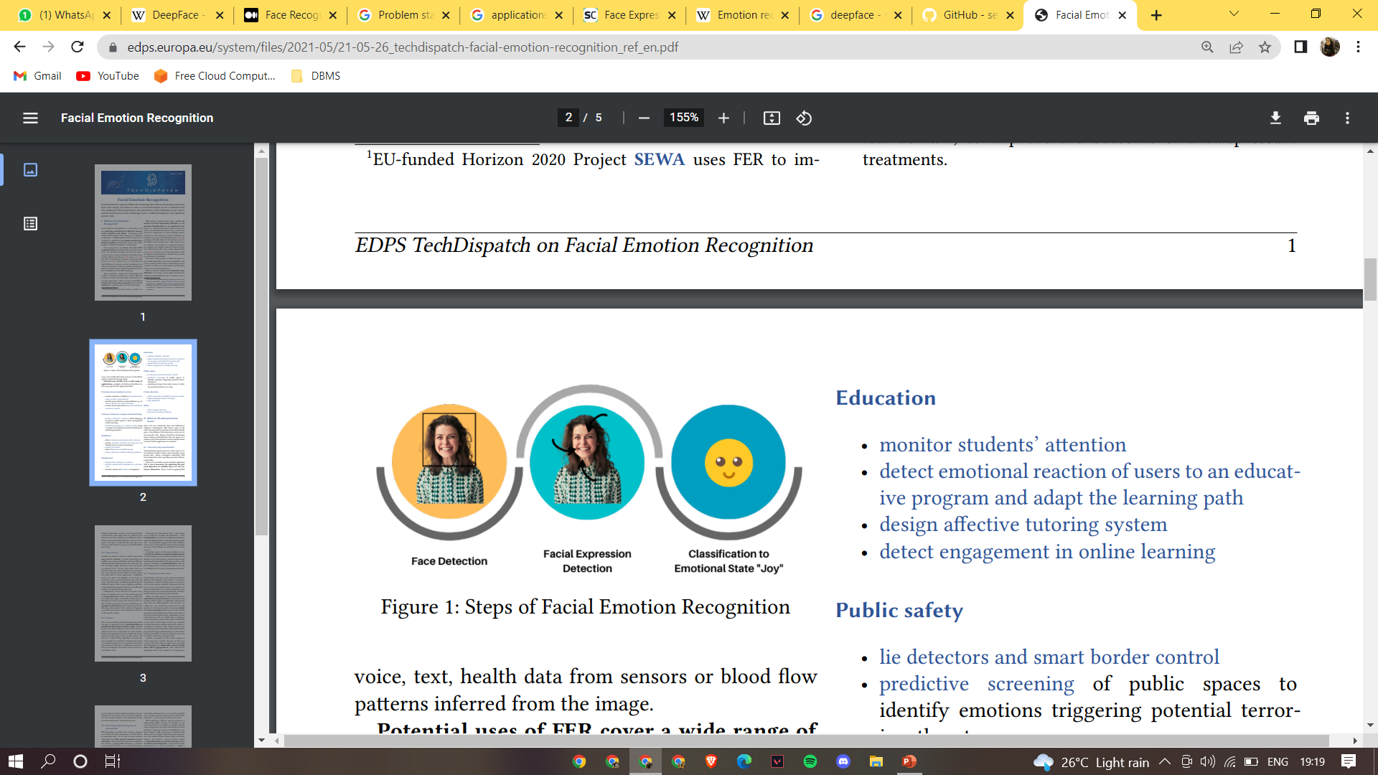

**Objectives**

Potential uses of FER cover a wide range of applications-

i) Provision of personalized services

ii) Customer behavior analysis and advertising

iii) Healthcare

iv) Employment

v) Education

vi) Public safety

vii) Crime detection

**Machine Learning Models Used**

1. Automated starting webcam and capturing image (Using cv2)

2. Processing of captured image in the backend (Using matplotlib and haarcascade)

i) Plotting according to the size of image

ii) Converting the captured image from BGR to RGB

iii) Identify and extract the face from the image and mark

3. Analyzing dominant emotion from facial expressions (Using deepface)

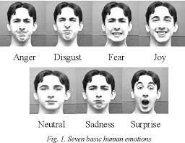

**Coding/IPYNB Notebooks**

<https://github.com/nidmehta/Summer-Training-2022/blob/main/Project/Emotion%20Recognition.ipynb>

**Screenshots of Model Deployment**

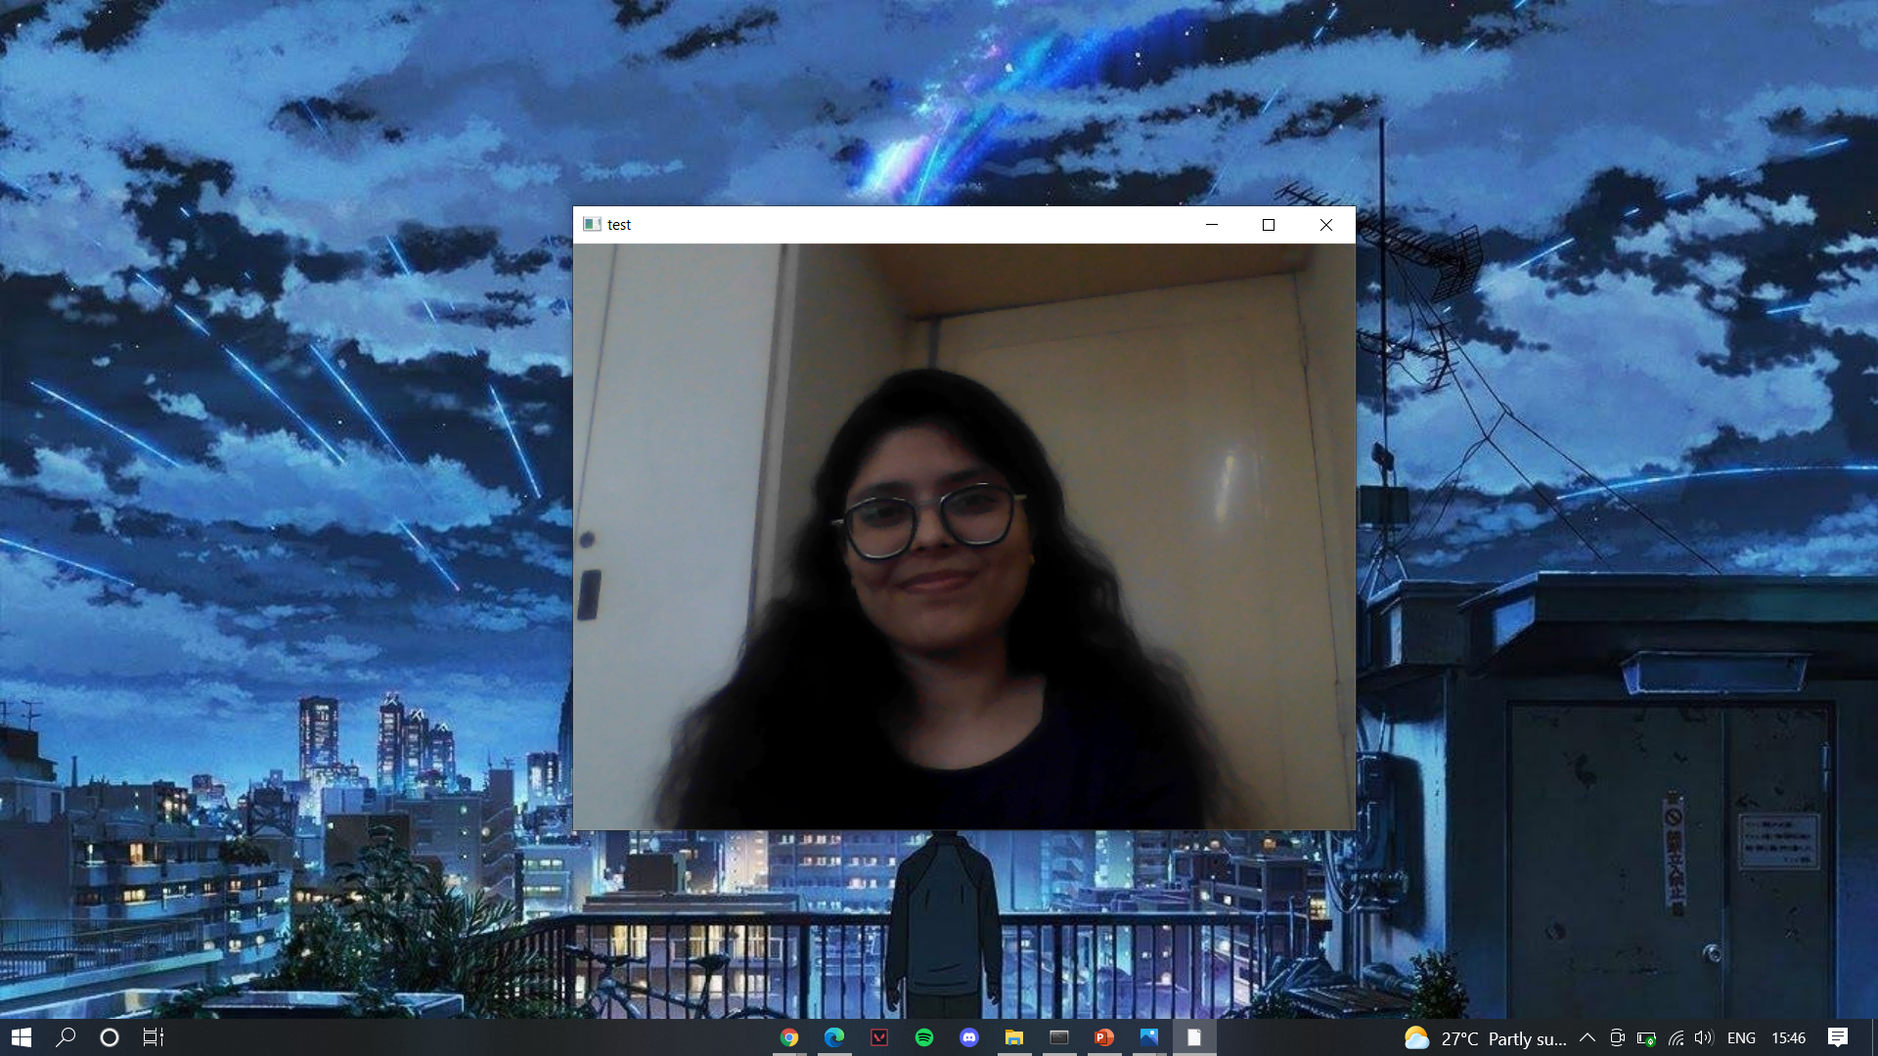

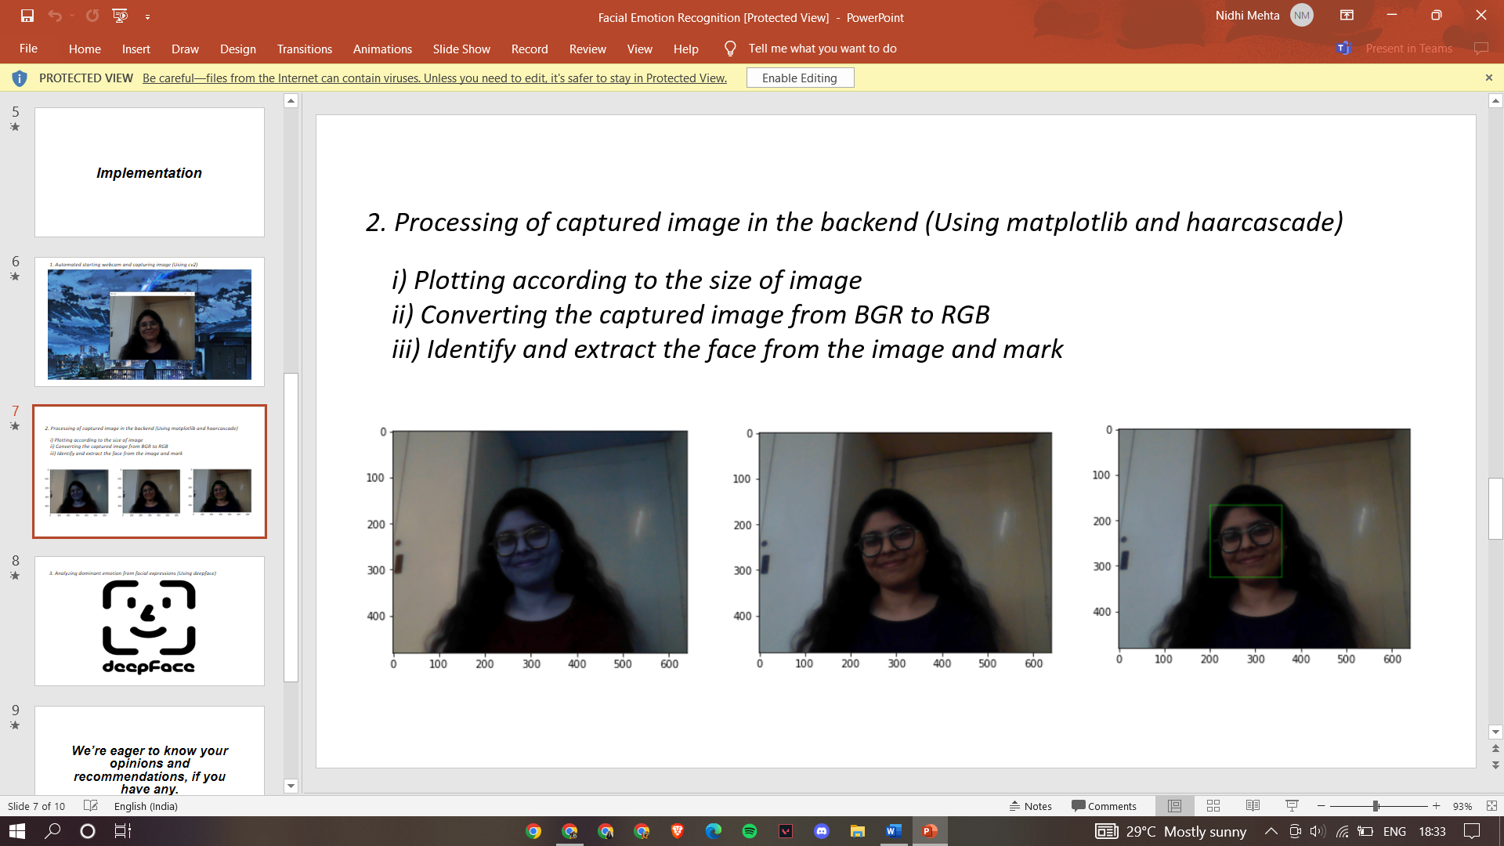

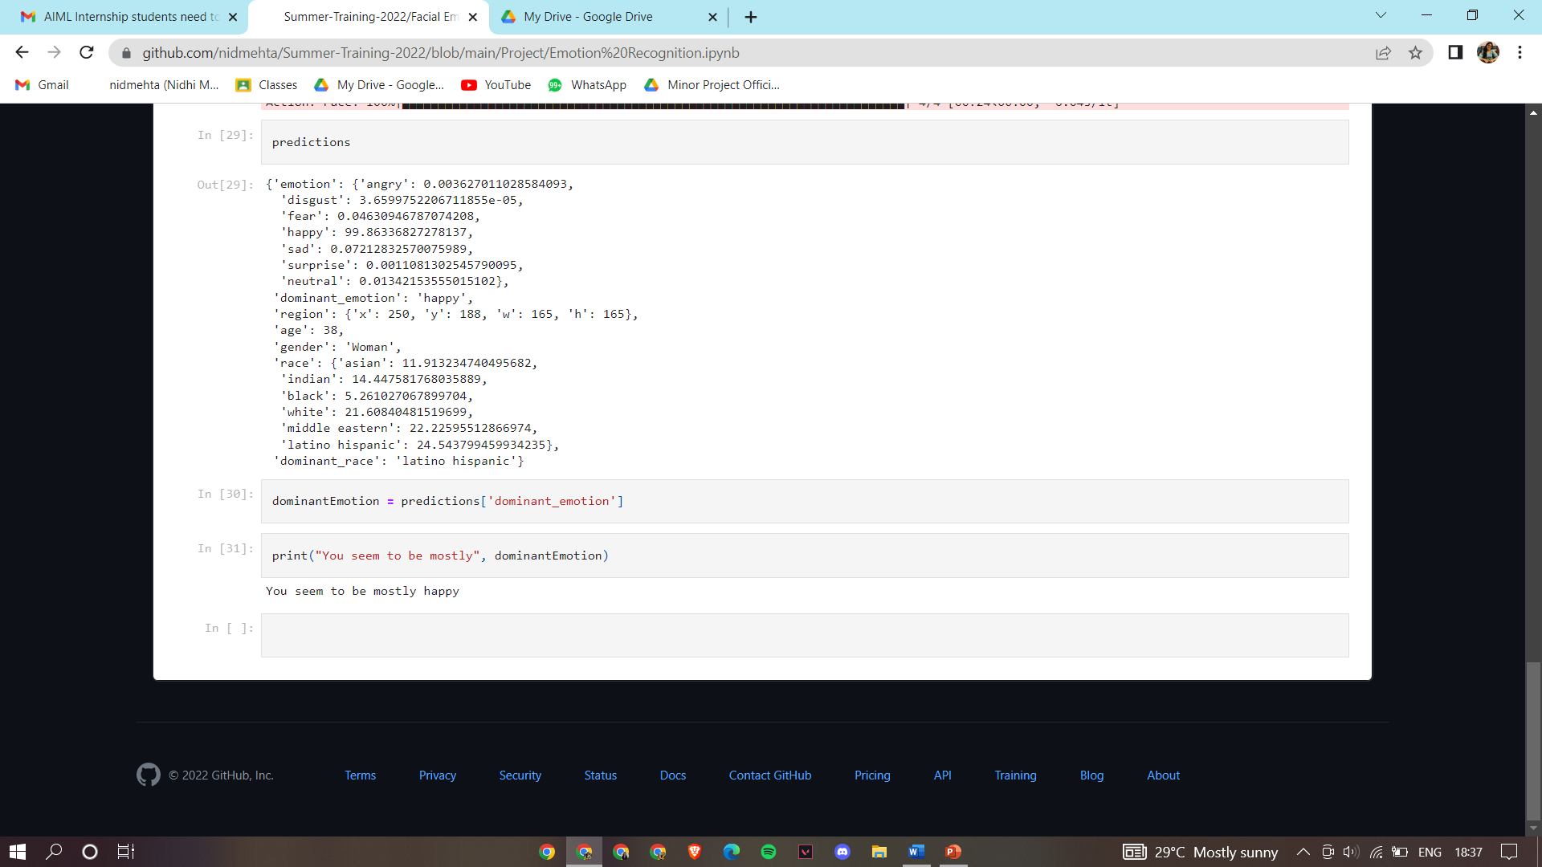

**Kaggle Account /GitHub Links ( showing your contribution and work)**

https://github.com/nidmehta/Summer-Training-2022/tree/main/Project

**Conclusion**

**References/ Bibliography**

[1]https://towardsdatascience.com/the-ultimate-guide-to-emotion-recognition-from-facial-expressions-using-python-64e58d4324ff

[2] https://www.irjet.net/archives/V7/i5/IRJET-V7I51409.pdf